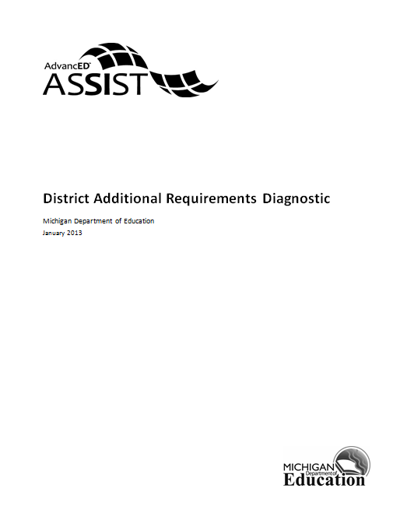

District Additional Requirements Diagnostic
This diagnostic contains certification requirements for Michigan districts. This diagnostic must be completed by all districts.

- The District School Improvement Team reviews the CIMS data.

- CIMS data is used to prepare our District Improvement Plan.

- The District Technology Protection Measure blocks or filters adult and student internet access to inappropriate materials (visual depictions that are obscene, child pornography, or harmful to minors).

- The district has a process to monitor adult and student use of the internet.

- The district has an Internet Safety Policy in place.

- The Internet Safety Policy meets the requirements as outlined in the state Technology Planning and CIPA requirements.

- The district has a process to provide public notice and hearings about the Internet Safety Policy.

- The district uses school-wide assessments to determine the telecommunication services and hardware support that are needed to support teaching and learning in all schools.

- The district uses the school-wide assessment data to identify the needs of the schools in the following areas: infrastructure (wiring, internet connections T1, etc.) in all classrooms, in all labs, in all media centers, in the main office, in counseling offices, in support staff offices; hardware; software; professional development. If "yes", specify the needs in the comments section.

- The district has identified specific actions that promote curriculum and teaching strategies to effectively integrate technology. If "yes", specify the actions in the comments section.

- The district adjusts its curriculum to include technology literacy for all students.

- The district adjusts its instructional program to promote technology literacy. If "yes", specify the adjustments in the comments section.

- The institution complies with all federal laws and regulations prohibiting discrimination and with all requirements and regulations of the U.S. Department of Education. It is the policy of this institution that no person on the basis of race, color, religion, national origin or ancestry, age, gender, height, weight, marital status or disability shall be subjected to discrimination in any program, service or activity for which the institution is responsible, or for which it receives financial assistance from the U.S. Department of Education.

- The institution has designated an employee to coordinate efforts to comply with and carry out non-discrimination responsibilities. If yes, list the name, position, address and telephone number of the employee in the comment field.

- The District has a District Board Policy that is related to Parent Involvement.

- The District has additional information necessary to support your improvement plan (optional).

