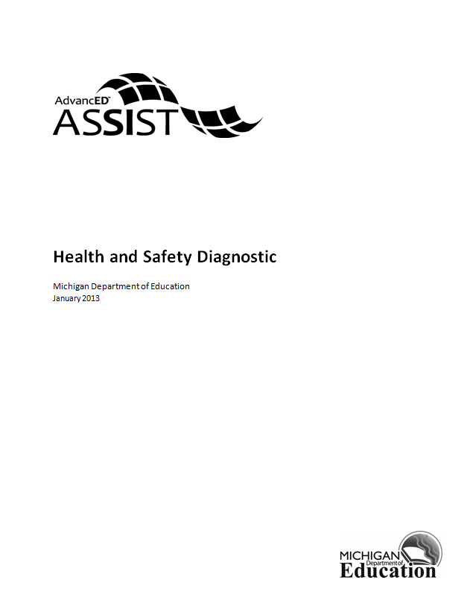

Health and Safety (HSAT) Diagnostic
The content for this tool comes directly from the Healthy School Action Tool (HSAT) Assessment (http://www.mihealthtools.org/hsat), an online tool for school buildings to assess its school health environments. These assurances are designed to help school improvement teams think about conditions for learning in their school, specifically related to student health and safety, and develop strategies in their school improvement plan to address any identified needs.

This diagnostic is optional and should be completed only if you took the HSAT.

1. Our School has a written policy on school safety that supports proactive, preventative approaches to ensure a safe school environment.
2. All teachers in our school have received professional development in management techniques to create calm, orderly classrooms.
3. Our school communicates all of our health and safety policies to students, staff, substitute teachers, parents and visitors through the parent handbook or newsletter at least once a year.
4. Our school has used data from a student health/safety assessment at least once in the past two years to assist in planning actions that will improve our school's environment and/or to determine the impact of changes that we have made on student attitudes and behaviors.
5. Our school has taken action on the Michigan State Board of Education Policy on Comprehensive School Health Education.
6. All teachers who provide health education instruction received annual professional development/continuing education specifically related to health education.
7. The health education curriculum used in our school is the Michigan Model for Health® Curriculum.
8. The health education curriculum used in our school involves student interaction with their families and their community.
9. Our school has taken action on the Michigan State Board of Education Policy on Quality Physical Education.
10. At our school, physical education teachers annually participate in professional development specific to physical education.
11. The physical education curriculum used in our school is: _____________.
12. At least three times during the past 12 months, our school offered programs, activities or events for families about physical activity.
13. Our school offers the following amount of total weekly minutes of physical education throughout the year.
14. Our school has taken action on the Michigan State Board of Education Policy on Nutrition Standards.
15. The food service director/manager participated in professional development related to food or nutrition during the past 12 months.
16. The food service director/manager supports/reinforces in the cafeteria what is taught in health education.
17. During the past 12 months, our school collected information from parents to help evaluate/improve school meals or foods offered a la carte, in concessions, school stores, vending machines, or as a part of classroom celebrations/parties or at school events.
18. Our school makes a good faith effort to ensure that federally reimbursable school nutrition programs are the main source of nutrition at school rather than vending or a la carte.
19. Our school has a health services provider or school nurse accessible to students.
20. Our school has a written policy on school safety that involves parents, and broader community, in collaborative efforts to help ensure a safe school environment.
21. Our school has a system in place for collecting relevant student medical information.
22. Our school has taken action on the Michigan State Board of Education Positive Behavior Support Policy.
23. During the past 12 months, the school counseling staff has provided professional development to school health staff about identification and referral of students related to violence and suicide prevention.
24. During the past 12 months, the school counselor/psychologist/social worker offered information to students (presentations, materials, individual or group counseling activities, events) about bullying, harassment and other peer to peer aggression.
25. During the past 12 months, the school counselor/psychologist/social worker has collaborated with appropriate school staff or community agencies to implement programs or activities related to bullying, harassment and other peer to peer aggression.
26. During the past 12 months, the school counseling staff identified students who are at risk of being victims or perpetrators of violence.
27. Our school's mission statement includes the support of employee health and safety.
28. During the past year, our school supported staff participation in health promotion programs by having a budget for staff health promotion.
29. During the past year, our school supported staff in healthy eating by providing healthy food choices at staff meetings.
30. Our school has a written family involvement policy that advocates for strong connections between the home, school and the community as a means of reducing barriers to student achievement.
31. Our school has a parent education program.
32. During the past 12 months, our school collected information from parents to help evaluate/improve school health education in our school.
33. During non-school hours the community has access to indoor facilities for physical activity (such as gym, weight room, hallway for walking, pool, basketball court).

