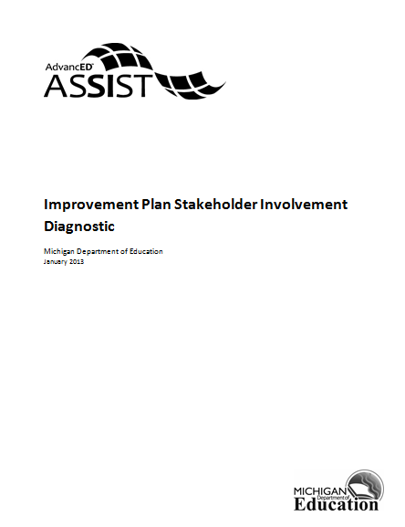

Improvement Plan Stakeholder Involvement Diagnostic

- Describe the process used to engage a variety of stakeholders in the development of the institution's improvement plan. Include information on how stakeholders were selected and informed of their roles, and how meetings were scheduled to accommodate them.

- Describe the representations from stakeholder groups that participated in the development of the improvement plan and their responsibilities in this process.

- Explain how the final improvement plan was communicated to all stakeholders, and the method and frequency in which stakeholders receive information on its progress.

