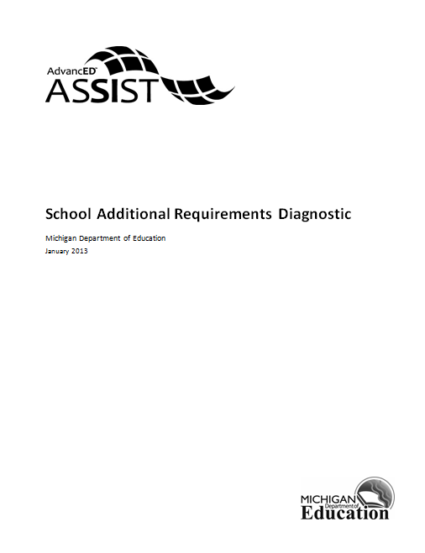

School Additional Requirements Diagnostic
This diagnostic contains certification requirements for Michigan schools. This diagnostic must be completed by all schools.

- Literacy and math are tested annually in grades 1-5.

- Our school published a fully compliant annual report. (The Annual Education Report (AER) satisfies this). If yes, please provide a link to the report in the box below.

- Our school has the 8th grade parent approved Educational Development Plans (EDPs) on file.

- Our school reviews and annually updates the EDPs to ensure academic course work alignment.

- The institution complies with all federal laws and regulations prohibiting discrimination and with all requirements and regulations of the U.S. Department of Education. It is the policy of this institution that no person on the basis of race, color, religion, national origin or ancestry, age, gender, height, weight, marital status or disability shall be subjected to discrimination in any program, service or activity for which the institution is responsible, or for which it receives financial assistance from the U.S. Department of Education.
References: Title VI of the Civil Rights Act of 1964, Section 504 of the Rehabilitation Act of 1973, The Age Discrimination Act of 1975, The Americans with Disabilities Act of 1990, Elliott-Larsen prohibits discrimination against religion.

- The institution has designated an employee to coordinate efforts to comply with and carry out non-discrimination responsibilities. If yes, list the name, position, address and telephone number of the employee in the comment field.

- The institution has a School-Parent Involvement Plan (that addresses Section 1118 activities) that is aligned to the District's Board Policy. If yes, please attach the School-Parent Involvement Plan below.

- The institution has a School-Parent Compact. If yes, please attach the School-Parent Compact below.

- The School has additional information necessary to support your improvement plan (optional).

