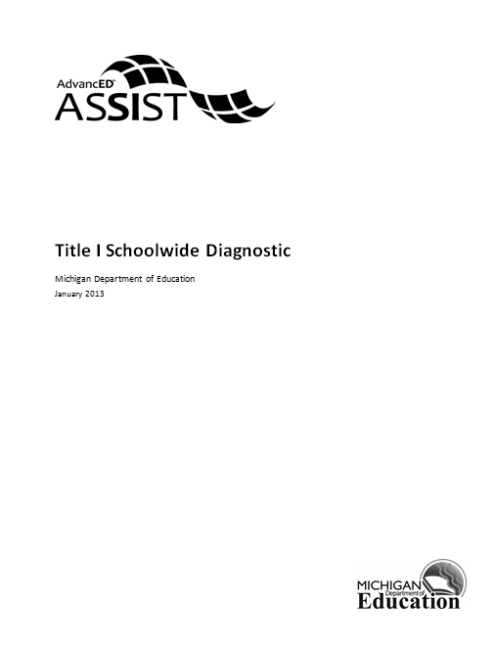
Title I Schoolwide Diagnostic
2014-15
Template with comments to meet MDE OFS Schoolwide Rubric Requirements

Developed by Sybil Lenzi
December 2013
This diagnostic tool is aligned to requirements for Title I Schoolwide schools. As described in sections 1111(b)(1), 1114 (b)(1)(A) and 1309(2) of the Elementary and Secondary Education Act (ESEA), the Comprehensive Needs Assessment (CNA) requirement is met by completing a School Data Analysis (SDA) and School Process Profile (SPP). The Comprehensive Needs Assessment must be completed prior to creating a new plan or annually updating an existing school improvement plan. Use the results of the Comprehensive Needs Assessment to develop Goals/Objectives/Strategies and Activities. Ensure that the Comprehensive Needs Assessment addresses all four types of data: student achievement data, school programs/process data, perceptions data (must include teachers and parents; student data is encouraged), and demographic data. The Comprehensive Needs Assessment must also take into account the needs of migratory children as defined in Title I, Part C, Section 1309(2).

Component 1: Comprehensive Needs Assessment
- How was the comprehensive needs assessment conducted?

- What were the results of the comprehensive needs assessment ? What information was concluded as a result of analyzing perception, student achievement, school programs/process, and demographic data?

- How are the school goals connected to priority needs and the needs assessment? It should be clear that a detailed analysis of multiple types of data was conducted to select the goals.

- How do the goals address the needs of the whole school population and special recognition to children who are disadvantaged?

Component 2: Schoolwide Reform Strategies
- Describe the strategies in the schoolwide plan which focus on helping ALL students reach the State’s standards.

- Describe how the research-based methods and strategies in the schoolwide plan increase the quality and quantity of instruction (which accelerates and enriches the curriculum).

- Describe how the research-based reform strategies in the schoolwide plan align with the findings of the needs assessment.

- Describe the strategies in the schoolwide plan which provide a level of INTERVENTIONS for students who need the most instructional support.

- Describe how the school determines if these needs of students are being met.

Component 3: Instruction by Highly Qualified Staff
- Do all of the instructional paraprofessionals meet the NCLB requirements for highly qualified? Provide an assurance statement. If no, what is the number that is not highly qualified and what is being done to address this?
NOTE: A schoolwide program must have all highly qualified instructional staff.

- Do all of the teachers meet the NCLB requirements for highly qualified? Provide an assurance statement. If no, what is the number that is not highly qualified and what is being done to address this?
NOTE: A schoolwide program must have all highly qualified instructional staff.

Component 4: Strategies to Attract Highly Qualified Teachers
- What is the school’s teacher turnover rate for this school year?

- What is the experience level of key teaching and learning personnel?

- Describe the specific initiatives the SCHOOL has implemented to attract and retain high quality teachers regardless of the turnover rate.

- Describe the specific initiatives the DISTRICT has implemented to attract and retain highly qualified teachers regardless of the turnover rate.

- If there is a high turnover rate, what initiatives has the school implemented to attempt to lower the turnover rate of highly qualified teachers?

Component 5: High Quality and Ongoing Professional Development
- Describe the professional development/learning that the staff will receive that is aligned with the comprehensive needs assessment and the goals of the school improvement plan.

- Describe how this professional development is “sustained and ongoing.”

- The school’s Professional Development/Learning plan is complete.
YES or NO. If no, explain WHY.

Attach a copy of your school’s professional development plan HERE.

Component 6: Strategies to Increase Parental Involvement
- Describe how parents are (will be) involved in the design of the schoolwide plan.

- Describe how parents are (will be) involved in the implementation of the schoolwide plan.

- Describe how parents are (will be) involved in the evaluation of the schoolwide plan.

- Does the school have a Title I Parent Involvement policy that addresses how the school carries out the required activities of ESEA Section 1118 (c) through (f)?
Yes or No. If NO, explain WHY.

A copy of the school level Parent Involvement Policy (plan) must be attached—HERE.

- Describe how the school is carrying out the activities outlined in ESEA Section 1118 (e ) 1-5, 14 and (f ).

- Describe how the parent involvement component of the schoolwide plan is (will be) evaluated.

- Describe how the results of the evaluation are (will be) used to improve the schoolwide program.

- Describe how the school-parent was compact developed.

- Describe how the parent compact is used at elementary-level parent teacher conferences.

- How is the parent compact shared with middle school or high school parents (depending on the grade span of the school)?

THE FOLLOWING NEEDS TO BE A SEPARATE ITEM. ALL TITLE I SCHOOLS MUST HAVE A SCHOOL-PARENT COMPACT. ALL TITLE I SCHOOLS MUST ATTACH THEIR COMPACT.
The School’s School-Parent Compact is attached.
Yes or NO. If NO, explain WHY.
NOTE: The School’s School-Parent Compact must be attached HERE.

- Describe how the school provides individual student academic assessment results in a language the parents can understand.

Component 7: Preschool Transition Strategies
- In what ways does the school connect with preschool age children more than a once a year visitation to the kindergarten classroom? NOTE: Middle and high schools are not required to address this question; however, schools targeting an “Exceptional” rating on the Title I Schoolwide rubric can provide information regarding transitioning efforts for entering or exiting students. Schools choosing not to respond should put “N/A” in the box below.

- What types of training does the school provide preschool parents and/or preschool teachers on the skills preschool age children will need when they enter kindergarten? NOTE: Middle and high schools are not required to address this question. Institutions that do not have preschool should put “N/A” in the box below.

Component 8: Teacher Participation in Making Assessment Decisions
- How do teachers provide their input into the decisions regarding the use of school-based academic assessments?

- How are teachers involved in student achievement data analysis for the purpose of improving the academic achievement of all students?

Component 9: Timely and Additional Assistance to Students Having Difficulty Mastering the Standards
- Describe the process to identify students who experience difficulty mastering the State’s academic achievement assessment standards at an advanced or proficient level.

- How is timely, effective, additional assistance provided to students who are experiencing difficulty mastering the State’s academic achievement assessment standards at an advanced or proficient level?

- How are students’ individual needs being addressed through differentiated instruction in the classroom?

Component 10: Coordination and Integration of Federal, State and Local Programs and Resources
- In what ways are the programs coordinated and integrated toward the achievement of the schoolwide goals? Include a LIST of the State, local and Federal programs/resources that will be supporting the schoolwide program.

- Describe how the school will use the resources from Title I and other State, local and Federal sources to implement the ten required schoolwide components.

- How does the school coordinate and integrate the following Federal, State and local services in a manner applicable to the grade level to support achievement of the schoolwide goals: violence prevention programs, nutrition programs, housing programs, Head Start, adult education, vocational and technical education, and job training.
NOTE: Not all schools receive all of the funding sources mentioned.

Evaluation:
- Describe how the school evaluates, at least annually, the implementation of the schoolwide program.

- Describe how the school evaluates the results achieved by the schoolwide program using data from the State’s annual assessments and other indicators of academic achievement.

- Describe how the school determines whether the schoolwide program has been effective in increasing the achievement of students who are furthest from achieving the standards.

- What process is followed by the school to revise the plan, as necessary, based on the evaluation, to ensure continuous improvement of students in the schoolwide program?

