Directions for accessing ASSIST

(Each picture is hyper-linked)

STEP #3

Proceed As Normal

Click ASSIST

Click Login Button

STEP #2

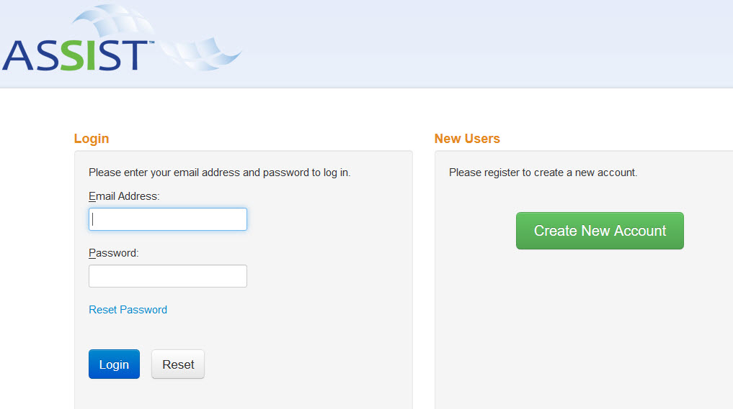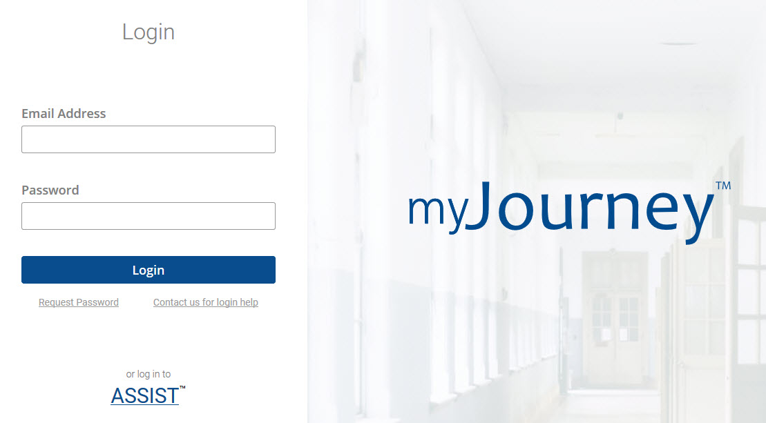

STEP #1

