Goal:
XXX: All students will be proficient in _______. (IF Academic Goal chosen – XXX simply abbreviation that will carry through the organization of this Goal, such as: RDG, MTH, SCI, SS, WRT, CCR, etc.)

OR IF Organizational Goal chosen -
XXX: Improve or Implement (district wide initiative such as: improving student engagement, strengthen the use of formative data in our PLC, implement Professional Learning Communities, implement a positive behavior system, etc.)

Objective: (Recommended to write a Tier 1 objective for ALL students)
(portion) of (subgroup or all students) will demonstrate a proficiency in (all ___ standards or a smaller portion) in (content chosen) by (date specified) as measured by (data specified).

i.e. 85% of all students will demonstrate a proficiency in all reading standards in ELA by 06/30/2022 as measured by state level assessment (currently MEAP/MME).

NOTE: Organizational goals are not attached to one specific content area and the objective has the same components minus the portion and subgroup.

Strategy Name:
XXX: Tier 1 General Name of Strategy
How will the strategy work?
Teachers will (describe what teachers do in the classroom with the students within the content).
State the research used to support this strategy:
According to MDE/OFS Protocol this section should:
- Identify the research that supports the Strategies
- Provide a brief summary of the research
Ex: Research – What Works Clearinghouse, Assisting Students Struggling with Mathematics, Response to Intervention (RTI) for Elementary and Middle Schools. Instruction during the intervention should be explicit and systematic.
NOTE: On Site Reviews in the past have also insisted on an APA citation of materials referenced.

Activity Name:
XXX 1.1 Brief Descriptive Name
Activity Type:
Professional Learning (from drop down menu)
Activity Description:
Describe what training may need to occur to support strategy ADD specific details here for Office of Field Services (when, where, total cost, etc.)
Dates: July 1 to June 30 Responsible Staff: position not name
Resources: Title II Part A $$$ (if applicable)

Activity Name:
XXX 1.2 Brief Descriptive Name
Activity Type:
Getting Started (from drop down menu)
Activity Description:
Describe what materials may need to be purchased.
Dates: July 1 to June 30 Responsible Staff: position not name
Resources: General Fund $$$ (if applicable)

Activity Name:
XXX 1.3 Brief Descriptive Name
Activity Type:
Getting Started (from drop down menu)
Activity Description:
Describe how this will be communicated, or rolled out, or what barriers need to be removed (such as scheduling issues)
Dates: July 1 to June 30 Responsible Staff: position not name

Activity Name:
XXX 1.4 Brief Descriptive Name
Activity Type:
Implementing (or Other from Drop down if this is not added yet)
Activity Description:
Describe specific activities of staff, non-negotiable(s) at the core level (Tier 1 only)
Dates: July 1 to June 30 Responsible Staff: Grade level teachers

Activity Name:
XXX 1.5 Brief Descriptive Name
Activity Type:
Implementing (or Other from Drop down if this is not added yet)
Activity Description:
Describe possible support structures to put in place, barriers to be removed, and/or instructional technology to be integrated
Dates: July 1 to June 30 Responsible Staff: Grade level teachers

Activity Name:
XXX 1.6 Brief Descriptive Name
Activity Type:
Monitoring (or Other from Drop down if this is not added yet)
Activity Description:
Describe how the strategy will be monitored and evaluated, both for teacher implementation and impact on student achievement
Dates: July 1 to June 30 Responsible Staff: position not name

Activity Name:
XXX 1.7 Brief Descriptive Name
Activity Type:
Parent Involvement (or Other from Drop down if this is not added yet)
Activity Description:
Describe how parent involvement has been planned (remember that at least 1% of Title I funds should be allocated to parent involvement)
Dates: July 1 to June 30 Responsible Staff: position not name
Resources: Title I-A $$$ (if applicable)

Objective: (Recommended to write Tier 2 objectives with 2nd data source)
(portion) decrease of all students will demonstrate a proficiency on (description of data) in (content area specified) by (date specified) as measured by (description of local assessment given).

i.e. A 30% decrease of all students will demonstrate a proficiency on our local reading benchmark by reducing the number of “At Risk” students from 50% (Winter 2013) to 20% (Spring 2014) in English Language Arts by 06/1/2014 as measured by NWEA/MAP Benchmark assessments given Fall, Winter, and Spring each year.

Strategy Name:
XXX: Tier 2 General Name of Strategy
How will the strategy work?
Teachers will (describe what teachers do with students regarding Tier 2 intervention).
State the research used to support this strategy:
According to MDE/OFS Protocol this section should:
- Identify the research that supports the Strategies
- Provide a brief summary of the research
Ex: Research – What Works Clearinghouse, Assisting Students Struggling with Mathematics, Response to Intervention (RTI) for Elementary and Middle Schools. Instruction during the intervention should be explicit and systematic.
NOTE: On Site Reviews in the past have also insisted on an APA citation of materials referenced.

Activity Name:
XXX 2.1 Brief Descriptive Name
Activity Type:
Getting Ready (or Other from drop down if this is not added yet)
Activity Description:
Describe any materials to be purchased or training that needs to occur. ADD specific details here for Office of Field Services (when, where, total cost, etc.)
Dates: July 1 to June 30 Responsible Staff: Building principal
Resources: Funding Source $$$ (if applicable)

Activity Name:
XXX 2.2 Brief Descriptive Name
Activity Type:
Implementation (from drop down menu)
Activity Description:
Describe activities to support at-risk students, include any costs with sufficient details to support Consolidated Application
Dates: July 1 to June 30 Responsible Staff: building principal & Tier 2 staff
Resources: Title I Part A $$$

Activity Name:
XXX 2.3 Brief Descriptive Name
Activity Type:
Monitoring (from drop down menu)
Activity Description:
Describe how the strategy will be monitored and evaluated, both for teacher implementation and impact on student achievement
Dates: July 1 to June 30 Responsible Staff: building principal & Tier 2 staff

Objective: (Write Tier 3 or subgroup objective and triangulate data)
(portion) decrease of all students will demonstrate a proficiency on (description of data) in (content area specified) by (date specified) as measured by (description of local assessment given).

i.e. A 15% decrease of all students will demonstrate a proficiency on our intense reading assessment by reducing the number of “At Risk” students from 20% (Winter 2013) to 5% (Spring 2014) in reading by 06/1/2014 as measured by Fontus/Pinnell assessments.
Strategy Name:
XXX: Tier 3 Brief, descriptive name
How will the strategy work?
Teachers will (describe what teachers do with students regarding Tier 3 intervention or specific support of a subgroup population addressed due to significant gaps).
State the research used to support this strategy:
According to MDE/OFS Protocol this section should:
- Identify the research that supports the Strategies
- Provide a brief summary of the research
Ex: Research – What Works Clearinghouse, Assisting Students Struggling with Mathematics, Response to Intervention (RTI) for Elementary and Middle Schools. Instruction during the intervention should be explicit and systematic.
NOTE: On Site Reviews in the past have also insisted on an APA citation of materials referenced.

Activity Name:
XXX 3.1 Brief Descriptive Name
Activity Type:
Getting Ready (or Other from Drop down if this is not added yet)
Activity Description:
Describe any materials to be purchased or training that needs to occur. ADD specific details here for Office of Field Services (when, where, total cost, etc.)
Dates: July 1 to June 30 Responsible Staff: Building principal
Resources: Funding Source $$$ (if applicable)

Activity Name:
XXX 3.2 Brief Descriptive Name
Activity Type:
Implementation (from drop down menu)
Activity Description:
Describe activities to support at-risk students, include any costs with sufficient details to support Consolidated Application
Dates: July 1 to June 30 Responsible Staff: building principal & Tier 3 staff
Resources: Title I Part A $$$

Activity Name:
XXX 3.3 Brief Descriptive Name
Activity Type:
Monitoring (from drop down menu)
Activity Description:
Describe how the strategy will be monitored and evaluated, both for teacher implementation and impact on student achievement
Dates: July 1 to June 30 Responsible Staff: building principal & Tier 3 staff

Strategy Name: (optional to include more than one strategy under objective)
XXX: Data? Brief, descriptive name
How will the strategy work?
Administrators and teachers will implement a system of data collection and analysis and data-based decision-making to support a three-tiered model of instructional intervention.
State the research used to support this strategy:
According to MDE/OFS Protocol this section should:
- Identify the research that supports the Strategies
- Provide a brief summary of the research
Ex: Research – What Works Clearinghouse, Assisting Students Struggling with Mathematics, Response to Intervention (RTI) for Elementary and Middle Schools. Instruction during the intervention should be explicit and systematic.
NOTE: On Site Reviews in the past have also insisted on an APA citation of materials referenced.

Activity Name:
XXX 4.1 Brief Descriptive Name
Activity Type:
Getting Ready (or Other from Drop down if this is not added yet)
Activity Description:
Describe any materials to be purchased or training that needs to occur. ADD specific details here for Office of Field Services (when, where, total cost, etc.)
Dates: July 1 to June 30 Responsible Staff: Building principal
Resources: Funding Source $$$ (if applicable)

Activity Name:
XXX 4.2 Brief Descriptive Name
Activity Type:
Implementation (from drop down menu)
Activity Description:
Describe activities to support at-risk students, include any costs with sufficient details to support Consolidated Application
Dates: July 1 to June 30 Responsible Staff: building principal & Tier 3 staff
Resources: Title I Part A $$$

Activity Name:
XXX 4.3 Brief Descriptive Name
Activity Type:
Monitoring (from drop down menu)
Activity Description:
Describe how the strategy will be monitored and evaluated, both for teacher implementation and impact on student achievement
Dates: July 1 to June 30 Responsible Staff: building principal & Tier 3 staff

APPENDIX A – Snapshot within the ASSIST platform

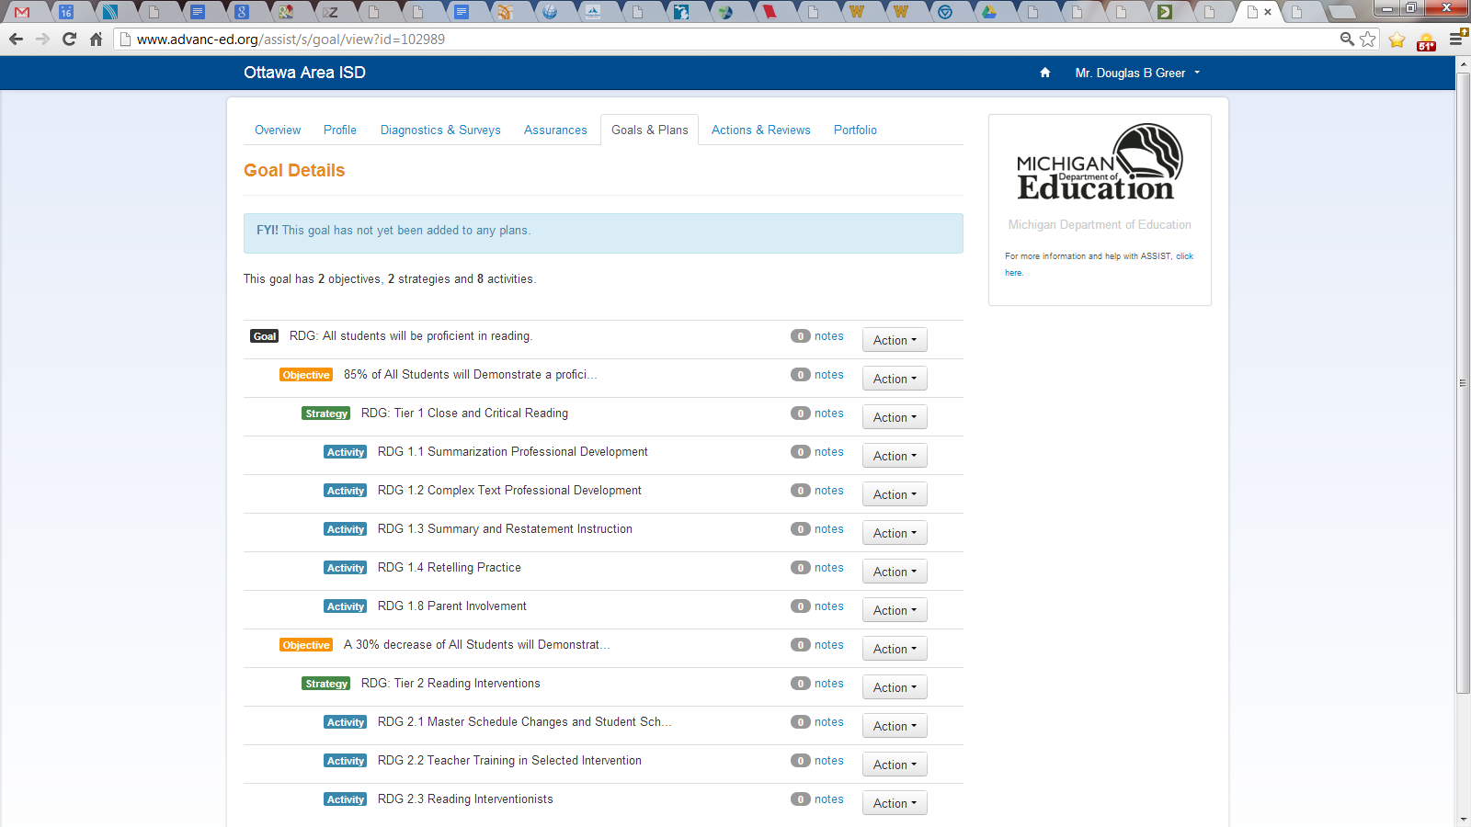
continued …

