

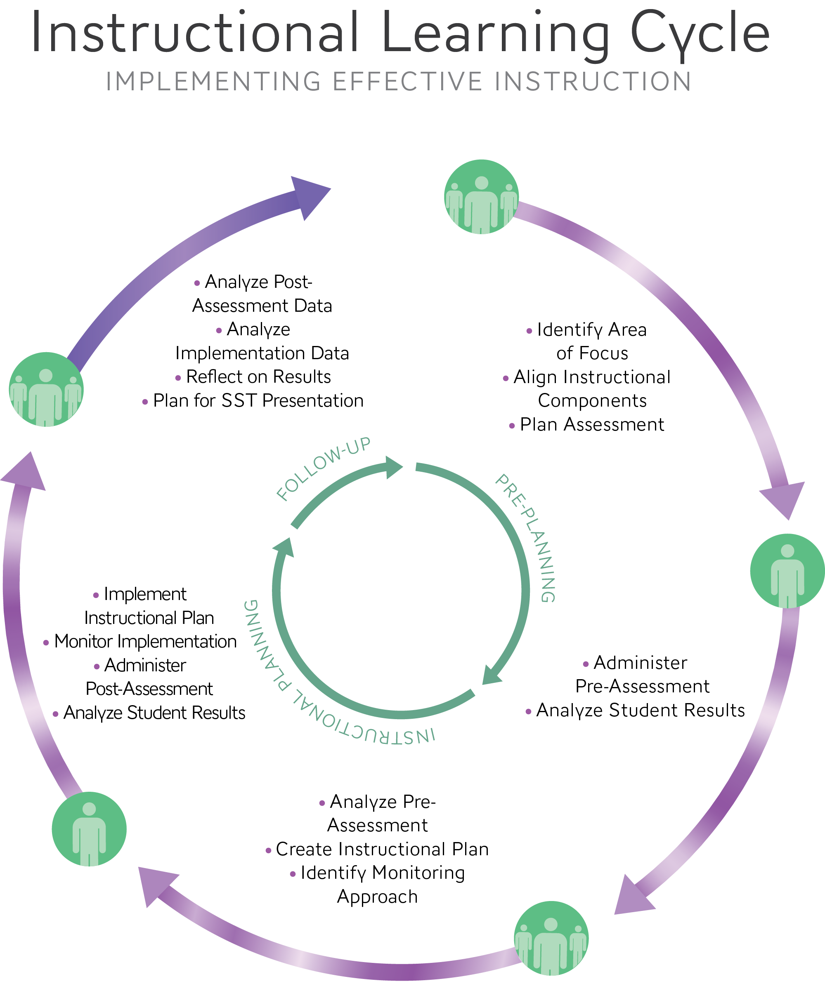

**School Name: Principal: Grade Level or Content Area:**

**Team Members: Date:**

|  |  |
| --- | --- |
|  | Pre-Planning |

**Identify Area of Focus**

1. **What are we supposed to be teaching during the next 3-5 weeks? Identify cycle begin and end dates.**

**Align Instructional Components**

1. **What are the state standard(s) we will be addressing that also connect to our R/R Plan?**
2. **Based on data, what learning targets from the identified state standard(s) will we emphasize during the next 3-5 weeks?**

**Plan Assessment**

1. **How do we assess the identified learning targets?**
2. **What does proficient student work look like for the identified learning targets?**

ACTIONS

|  |  |  |
| --- | --- | --- |
| **At End of Meeting** | **Dates** | **In Classroom** |
| * *Identify Pre-Assessment Date* * *Identify Instructional Planning Meeting Date* |  | * Administer Pre-Assessment * Analyze Student Results |
|  |

|  |  |
| --- | --- |
|  | Classroom Results Pre-Assessment |

|  |  |  |
| --- | --- | --- |
| **Teacher name** | **Class** | **Date** |
| **Learning Targets**: | | |
| **Students at or above Proficient** | | |
| **Number of students =** | **Percent of Students =** | |
| **Student Names and Strengths** | **Challenges and next steps** | |
| **Students Close to Proficient** | | |
| **Number of students =** | **Percent of Students =** | |
| **Student Names and Strengths** | **Challenges and next steps** | |
| Students Far from Proficient | | |
| **Number of students =** | **Percent of Students =** | |
| **Student Names and Strengths** | **Challenges and next steps** | |

|  |  |
| --- | --- |
|  | Instructional Planning |

**Analyze Pre-Assessment Data**

1. **Record individual teacher results and combined results on pre-assessment**

|  |  |  |  |  |  |
| --- | --- | --- | --- | --- | --- |
| **Description of group** | **Individual classroom results** | **Individual classroom results** | **Individual classroom results** | **Individual classroom results** | **Combined classroom results** |
| **% of Students at or above proficient** |  |  |  |  |  |
| **% of Students close to proficient** |  |  |  |  |  |
| **% of Students far from proficient** |  |  |  |  |  |

1. **What patterns emerged from our pre-assessment data? Do our data confirm that this is a high need area?**

**Create Instructional Plan**

1. **Based on student data, what content will be used and what instructional strategies will be implemented to achieve the learning targets? How will the chosen instructional strategies be implemented?**
2. **How will we plan differently for students who are already proficient, close to proficient and far from proficient?**

**Identify Monitoring Approach**

1. **How will we monitor how closely we follow our instructional plan? What data will we collect on adult implementation?**

ACTIONS

|  |  |  |
| --- | --- | --- |
| **At End of Meeting** | **Dates** | **In Classroom** |
| * *Identify Post-Assessment Date* * *Identify Date for Follow-up Meeting* |  | * Implement Instructional Plan * Monitor Implementation * Administer Post Assessment * Analyze Student Results |
|  |

|  |  |
| --- | --- |
|  | Classroom Results Post-Assessment |

|  |  |  |
| --- | --- | --- |
| **Teacher name** | **Class** | **Date** |
| **Learning Targets:** | | |
| **Students at or above Proficient** | | |
| **Number of students =** | **Percent of Students =** | |
| **Student Names and Strengths** | **Challenges and next steps** | |
| **Students Close to Proficient** | | |
| **Number of students =** | **Percent of Students =** | |
| **Student Names and Strengths** | **Challenges and next steps** | |
| **Students Far from Proficient** | | |
| **Number of students =** | **Percent of Students =** | |
| **Student Names and Strengths** | **Challenges and next steps** | |

|  |  |
| --- | --- |
|  | Follow-Up |

**Analyze Post Assessment Data**

1. **Record individual teacher results and combined results.**

|  |  |  |  |  |  |  |
| --- | --- | --- | --- | --- | --- | --- |
| **Description of group** | **Individual classroom results** | **Individual classroom results** | **Individual classroom results** | **Individual classroom results** | **Combined classroom results** | **Change in proficiency** |
| **Students at or above proficient** |  |  |  |  |  |  |
| **Students close to proficient** |  |  |  |  |  |  |
| **Students far from proficient** |  |  |  |  |  |  |

1. **What conclusions can we draw about student learning based on our data?**
2. **Describe the movement of students between proficiency levels from the pre to post assessment?**

**Analyze Implementation Data**

1. **Record data collected on monitoring of implementation**

|  |  |
| --- | --- |
| **Teacher Name** | **Evidence of Implementation (Refer to Instructional Planning Document)** |
|  |  |
|  |  |
|  |  |

***\*Or insert your own table that captures your implementation data***

1. **What did we learn from our implementation data?**

**Reflect on Results**

1. **How did the way we actually implemented the instructional plan influence our student results?**
2. **What did we learn from this process about student learning and teacher practice?**
3. **What are our next steps? Are we ready to move on to a new area of focus? Or do we need to adjust our instructional plan and re-teach?**

ACTIONS

|  |  |
| --- | --- |
| **At End of Meeting** | * Identify Next Steps (based on #8) * Plan for SST Quarterly Meeting Presentation (or set date to do so) |