Creating your Goal and Measurable Objective Statements
Step 1: Goal Name (formerly the Goal Statement)
- All students will be proficient in ___________ (content area)
Choose Academic or Organizational Goal. An academic goal is a goal on one of the five content areas. An organizational goal is one around other criteria such as revamping the school structure, school culture/climate, student behavior, etc. (e.g. PBIS, Capturing Kids Hearts, Diversity, Dropout Prevention)
Step 2: Objective – e.g. 83% of Kindergarten, First, Second, Third, Fourth and Fifth grade students will demonstrate a proficiency in number fluency in Mathematics by 5/15/2014 as measured by Spring, 2014 NWEA MAP.
- Who? - Select the target population for your objective. To choose any members of a group - female or male, specific grades, or specific subgroup(s) -, you must first select the box next to the category (Particular Gender, Particular Grades, Particular Subgroup). To choose all grades in a building, you must select all of the boxes under Particular Grades. Click Next.
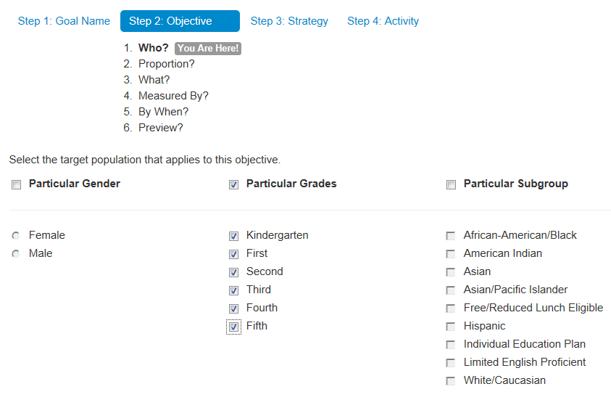

83% of Kindergarten, First, Second, Third, Fourth and Fifth grade students will demonstrate a proficiency in number fluency in Mathematics by 5/15/2014 as measured by Spring, 2014 NWEA MAP.
- Proportion? - The proportion of students your school desires to achieve the goal. This will be determined by your annual measureable objective (AMO) sent by the Bureau of Assessment and Accountability (BAA). Click Next.
  - Proportion - choose “A percentage” in the dropdown menu.
  - How many? – Choose the number at or above the AMO sent by the state.
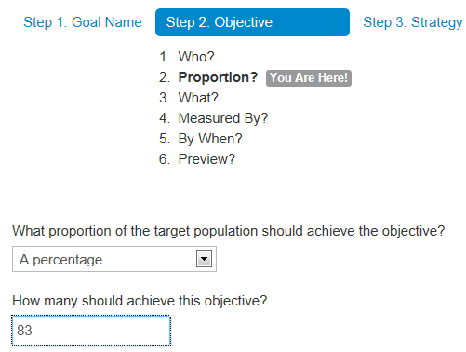
83% of Kindergarten, First, Second, Third, Fourth and Fifth grade students will demonstrate a proficiency in number fluency in Mathematics by 5/15/2014 as measured by Spring, 2014 NWEA MAP.

- What? - Identify the broad content area, what the target population will be doing, and the depth to which they will demonstrate the content knowledge. Click Next.
  - Content Area – Choose a content area. For reading and writing, choose English Language Arts. You can specify “Reading” in the next box.
  - Target Population – Choose “Demonstrate a proficiency” from the dropdown.
  - For the next box, indicate the strand, e.g. “in number fluency” or “in comprehension of informational text”
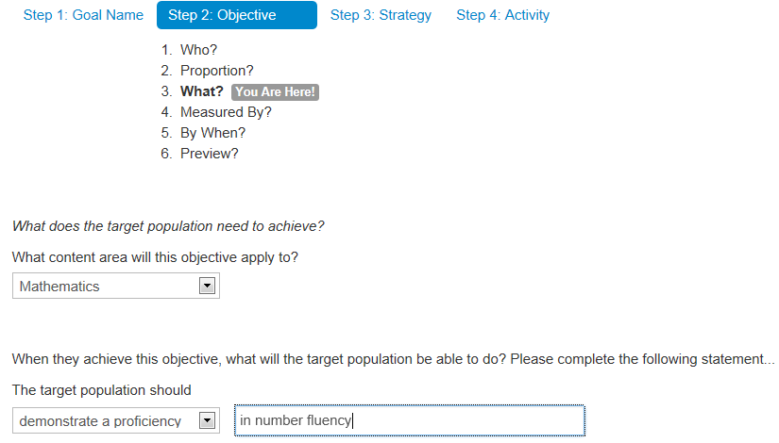

83% of Kindergarten, First, Second, Third, Fourth and Fifth grade students will demonstrate a proficiency in number fluency in Mathematics by 6/02/2014 as measured by Spring, 2014 NWEA MAP.

- Measured by? - The tool that will be used to measure student growth. Click Next.
  - Indicate the measurement tool and administration date of the tool, E.g. Spring, 2014 NWEA MAP, Discovery Ed. or District Common Math Assessment.
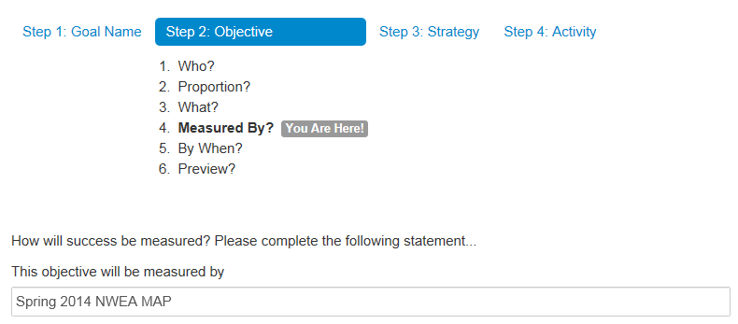
83% of Kindergarten, First, Second, Third, Fourth and Fifth grade students will demonstrate a proficiency in number fluency in Mathematics by 5/15/2014 as measured by Spring, 2014 NWEA MAP.

- By When? - Choose a calendar date for the completion of the objective. Then click on Preview to see your statement. Click Next.
  - Click on the open box next to the Calendar icon. You must choose a specific year, month and day on the pop-up calendar.
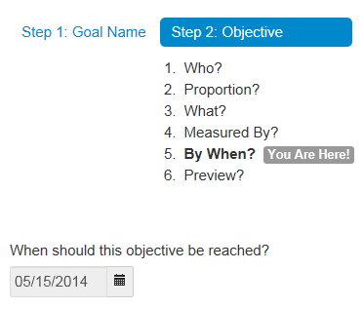
83% of Kindergarten, First, Second, Third, Fourth and Fifth grade students will demonstrate a proficiency in number fluency in Mathematics by 5/15/2014 as measured by Spring, 2014 NWEA MAP.
- Preview - Your goal displays as a sentence. Choose the “Back” button to edit pieces of your objective if needed. Choose “Accept and Continue” if your objective is correct.

